CSCE 2214
Lab Report
__________
Logan Campbell
Student ID: 010 641 227
Lab 09

Introduction

In lab 9 we will add on to the previous labs which consists of an M.I.P.S processor which has logic gates, multiplexers, a full adder, a register file, an arithmetic logic unit, control unit, and a data memory unit. From here the main part of lab 9 enabling the user to execute any instruction type (I type or R type instruction), use store, load, or set on less than instructions with the possibility of using immediate values for these instructions. As well adding functionality for doing a range of instructions, where it is provided within the test bench. In order for this to happen we have to add a program counter and instruction memory to our design.

Approach

In order to enable the user to automatically do a range of instructions and execute them we need to add the program counter and instruction memory units into the m.i.p.s processor. Program counter is a register that contains the address (the location) of a given instruction at this point of time (when it executes). As the instruction is carried out, the instruction is loaded into the instruction memory register and after the processor fetches it from the memory location from the program counter where it is held until it finally executes. In summary, the program counter is able to cycle through each instruction while the instruction memory contains the current instruction memory. For which it can cycle through the set of instructions and execute each on at a time.

Experimentation

The design at first would only execute the instructions hardcoded but since an instruction memory unit is added into memory we initialize a file which provides the instructions to run. The program counter acts as a register that stores the value of its input (PC + 2). The reason why the program counter is incremented by two every clock cycle is because each instruction is encoded by 2 bytes (16 bits), therefore, each line of the instruction file holds a half instruction. So we are given a set of instruction from the lab to implement into instruction memory. In order to get these instructions into a binary we must convert each instruction from hexadecimal to binary so the instructions can be executed. We used a converter to convert each operation, the register(s) file(s), and numbers to binary for them to execute shown below:

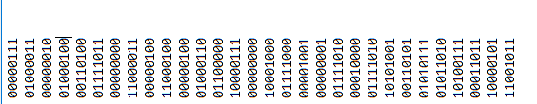

After the set of instruction are in the instruction memory each instruction is cycled through where it held in memory and executed. By doing so the program counter adds 2 bytes to cycle through the next instruction in sequence. The results of the given test bench is provided below in the results.

Results

Since we know from the previous labs what the processor is doing. It grabs an instruction executes it by going through seeing what type of instruction, the operation code, and the execution. All of this involves the different units. Now we want to execute the instruction memory into the MIPS processor. From the instruction txt file we are able to run the code and find the final solutions in the wave provided here:

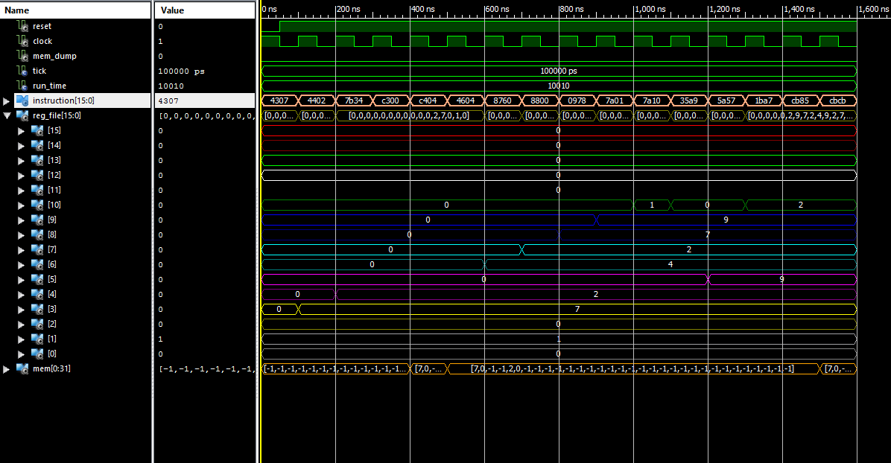

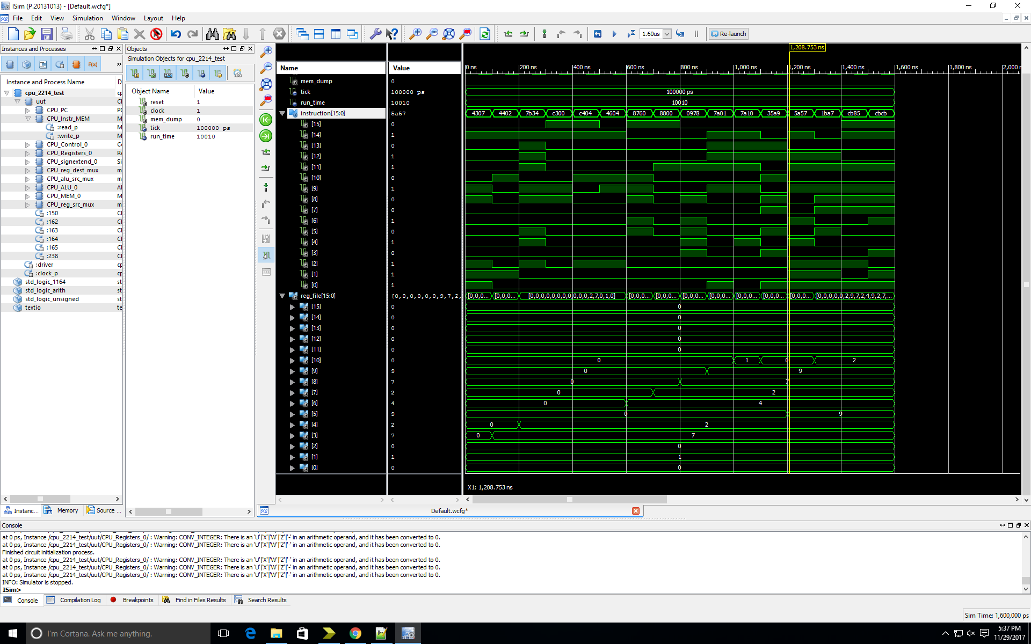

Conclusion

In conclusion everything worked out quite well, Understanding the program counter and instruction memory was fairly straight forward. Connecting the certain signals and instruction memory to data memory and having the program counter to be incremented by two was interesting. The signal assignation through me off, but it made sense in the end. Thought it was pretty neat that we created a mips processor from scratch. With basic logic gates, a mux, full adders, register files, and the different units (which were using register files). Very nice lab(s). TA was cool and so was the work.

